MLA General Format
MLA Style specifies guidelines for formatting manuscripts and citing research in writing. MLA Style also provides writers with a system for referencing their sources through parenthetical citation in their essays and Works Cited pages.
Cite your source automatically in MLA

Writers who properly use MLA also build their credibility by demonstrating accountability to their source material. Most importantly, the use of MLA style can protect writers from accusations of plagiarism, which is the purposeful or accidental uncredited use of source material produced by other writers.
If you are asked to use MLA format, be sure to consult the MLA Handbook (9th edition). Publishing scholars and graduate students should also consult the MLA Style Manual and Guide to Scholarly Publishing (3rd edition). The MLA Handbook is available in most writing centers and reference libraries. It is also widely available in bookstores, libraries, and at the MLA web site. See the Additional Resources section of this page for a list of helpful books and sites about using MLA Style.
Paper Format
The preparation of papers and manuscripts in MLA Style is covered in part four of the MLA Style Manual. Below are some basic guidelines for formatting a paper in MLA Style:
General Guidelines
Type your paper on a computer and print it out on standard, white 8.5 x 11-inch paper.
Double-space the text of your paper and use a legible font (e.g. Times New Roman). Whatever font you choose, MLA recommends that the regular and italics type styles contrast enough that they are each distinct from one another. The font size should be 12 pt.
Leave only one space after periods or other punctuation marks (unless otherwise prompted by your instructor).
Set the margins of your document to 1 inch on all sides.
Indent the first line of each paragraph one half-inch from the left margin. MLA recommends that you use the “Tab” key as opposed to pushing the space bar five times.
Create a header that numbers all pages consecutively in the upper right-hand corner, one-half inch from the top and flush with the right margin. (Note: Your instructor may ask that you omit the number on your first page. Always follow your instructor's guidelines.)
Use italics throughout your essay to indicate the titles of longer works and, only when absolutely necessary, provide emphasis.
If you have any endnotes, include them on a separate page before your Works Cited page. Entitle the section Notes (centered, unformatted).
Formatting the First Page of Your Paper
Do not make a title page for your paper unless specifically requested or the paper is assigned as a group project. In the case of a group project, list all names of the contributors, giving each name its own line in the header, followed by the remaining MLA header requirements as described below. Format the remainder of the page as requested by the instructor.
In the upper left-hand corner of the first page, list your name, your instructor's name, the course, and the date. Again, be sure to use double-spaced text.
Double space again and center the title. Do not underline, italicize, or place your title in quotation marks. Write the title in Title Case (standard capitalization), not in all capital letters.
Use quotation marks and/or italics when referring to other works in your title, just as you would in your text. For example: Fear and Loathing in Las Vegas as Morality Play; Human Weariness in "After Apple Picking"
Double space between the title and the first line of the text.
Create a header in the upper right-hand corner that includes your last name, followed by a space with a page number. Number all pages consecutively with Arabic numerals (1, 2, 3, 4, etc.), one-half inch from the top and flush with the right margin. (Note: Your instructor or other readers may ask that you omit the last name/page number header on your first page. Always follow instructor guidelines.)
Here is a sample of the first page of a paper in MLA style:
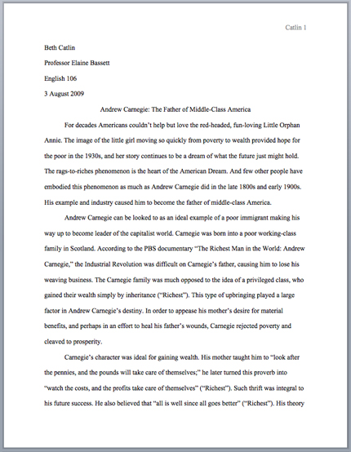
The First Page of an MLA Paper
Section Headings
Writers sometimes use section headings to improve a document’s readability. These sections may include individual chapters or other named parts of a book or essay.
Essays
MLA recommends that when dividing an essay into sections you number those sections with an Arabic number and a period followed by a space and the section name.
1. Early Writings
2. The London Years
3. Traveling the Continent
4. Final Years
Books
MLA does not have a prescribed system of headings for books (for more information on headings, please see page 146 in the MLA Style Manual and Guide to Scholarly Publishing, 3rd edition). If you are only using one level of headings, meaning that all of the sections are distinct and parallel and have no additional sections that fit within them, MLA recommends that these sections resemble one another grammatically. For instance, if your headings are typically short phrases, make all of the headings short phrases (and not, for example, full sentences). Otherwise, the formatting is up to you. It should, however, be consistent throughout the document.
If you employ multiple levels of headings (some of your sections have sections within sections), you may want to provide a key of your chosen level headings and their formatting to your instructor or editor.
Sample Section Headings
The following sample headings are meant to be used only as a reference. You may employ whatever system of formatting that works best for you so long as it remains consistent throughout the document.
Numbered:
1. Soil Conservation
1.1 Erosion
1.2 Terracing
2. Water Conservation
3. Energy Conservation
Formatted, unnumbered:
Level 1 Heading: bold, flush left
Level 2 Heading: italics, flush left
Level 3 Heading: centered, bold
Level 4 Heading: centered, italics
Level 5 Heading: underlined, flush left

